Professional Development assignment

1. The topic you will teach and why you chose this topic; what need(s) it meets for your teachers. You must document either by needs assessment survey or through conversations with staff, principal, etc. why you are doing this session. What need does it meet?
For my professional development project, I taught met with 3rd, 4th, and 5th grade teachers at Cornelius Elementary School to show them different public library databases they could use with their students to complete research projects. Charlotte Mecklenburg public library has a partnership with Charlotte Mecklenburg schools called ONE access where students can access all public library digital resources using their student ID number instead of a physical library card. This year, teachers were also allowed to access these digital resources using only their employment ID numbers. Based on conversations with the current media specialist, she had not had a chance to instruct teachers on the benefits of public library resources for their classes. The media specialist felt that the school doesn’t really have a lot of database resources for their students other than NC Wise Owl and Britannica, so having additional databases would certainly help upper elementary students with their research projects. Because the school operates on a fixed schedule co-teaching and even collaborative teaching is often times impossible. So the media specialist had no way of showing these teachers how to use these resources unless she did a video tutorial, which she felt teachers wouldn’t watch, or a before or after school session, which she didn’t feel would be well attended.
2. Any communication with participants to setup the session; how you advertise and coordinate the session.
I first got in contact with the Dean of Students at Cornelius Elementary to find out the best way to connect with each grade level’s team planning period.She arranged the dates and times for me to present to each grade for 15 minutes each. Prior to this, however, I emailed the lead teacher from 3rd, 4th, and 5th grade to see if they could tell me what research projects they had coming up for the rest of the year. That way, I was able to research their topics ahead of time to be able to suggest specific searches within specific databases to help their students. Here are the email responses below:

Molly East, 5th grade
Good morning. We are excited to see what have to share with us.
For science we will be working on our standard about weather. We look at local and global weather patterns.
For Social Studies
The topics are : Revolutionary War Battles: Northern, Middle, and Southern
The battle of Saratoga
The battle of Bunker Hill
The Battle of Trenton
The Battle at Brandywine
The Battle of Charleston
The Battle at Kings Mountain
Students will research two of these Battles of the Revolutionary War to tell:
Where
Details of the Battles
The importance of the battle to the outcome of the Revolutionary War.
Amy Fitchett, 4th grade
Hi Megan,
The fourth grade team will be finishing up a unit that involves researching a famous person from the American Revolution, and then will be taking a short break from research writing. We still would love to hear about any resources you might have, and are thrilled to have you so close by:). Because of the snow day today, I will check with Mrs. Moore but our planning day may be the 26th instead of the 25- I just wanted to give you that head's up. I'll go back and look at the Master Calendar and get back to you asap.
Take care and thank you for all you do!

Lindsey Yates, 3rd grade
Good afternoon! I am the lead teacher for 3rd grade at Cornelius and we are looking forward to speaking with you on January 26.
Some of the topics we are going to be discussing are:
1. researching famous African Americans for Black History month for a writing project with a timeline.
2. We will also be researching entrepreneurs in a few weeks.
3. In science will be discussing force and motion.
Hopefully this helps you. : )
Thanks!
(3) Detailed lesson plan for the instruction.
I’m attaching the powerpoint I used for some of my presentation. As shown, I first reviewed what ONE access is and that starting this school year, teachers all had an ecard that they could use to access all the databases I was about to talk about. I highlighted a couple other underutilized resources including the hotspot and tutor.com, which students can use to get free homework help in the evenings and afternoons in both English and Spanish.

Then I spoke specifically about resources that would benefit each grade level with their specific research projects. I pulled each database up on the smartboard and showed the teachers where to click and what to search to access specific information. Below is what I discussed and the databases are in bold:

3rd grade
1. researching famous African Americans for Black History month for a writing project with a timeline.
- World Book Encyclopedia online - kids - important people - type in name of African American or just “African American” - click on “view more information about this topic in world book student” OR click on - student - take me to - biography center - type in name of person, restrict categories, or select subject from list
- Gale Virtual Reference Library - type in African American’s name or search these specific encyclopedias “Encyclopedias of African American Culture and History”
- NCpedia - biographies - African American biographies (just of people from NC)

2. We will also be researching entrepreneurs in a few weeks.
- World book encyclopedia online - student - take me to - biography center - type in name of person, restrict categories, or select “inventors” from list

3. In science will be discussing force and motion.
- Power knowledge -physical science - force and motion - gravity; motion in our world; simple machines; all about force and motion; force and motion; force and motion with graphic organizers; Isaac Newton and Laws of Motion
- (more high school) - Science in Context - physics and astronomy - select force or motion
- (more high school) Access Science - type in force or motion

4th grade
researching a famous person from the American Revolution
- Gale Virtual Reference Library - “American Revolution” - second result “American Revolution (1775-1783), Gale Encyclopedia of U.S. History: War - lists some key figures
- World book encyclopedia - student - “ American Revolutionary War” - first one “American Revolution” - click on “related information” tab across the top - links to list of American military leaders, American civilian leaders, British leaders, and other biographies
- http://www.history.com/topics/american-revolution - History Channel - key battles and players
- http://www.theamericanrevolution.org/people.aspx - list of people
- http://www.campaign1776.org/revolutionary-war/key-figures-patriots.html?referrer=https://www.google.com/ - From the Civil War Trust

5th grade
For science we will be working on our standard about weather. We look at local and global weather patterns.
- Power knowledge - earth space science - climate change; everyday weather and seasons; extreme weather; temperature; weather and green energy; weather emergencies; weather maps; weathering and erosion; all about preparing for a natural disaster; four seasons; water in the atmosphere; weather with graphic organizers
- (more high school) - Science in Context - search “weather” or “climate” or “weather modeling” for experiments and articles
- (more high school) - Access Science - search “weather” or “climate” for articles
For Social Studies
Students will research two of these Battles of the Revolutionary War to tell:
Where
Details of the Battles
The importance of the battle to the outcome of the Revolutionary War.

- Gale Virtual Reference Library - “American Revolution” - second result “American Revolution (1775-1783), Gale Encyclopedia of U.S. History: War - lists some key battles
- World book encyclopedia - student - “ American Revolutionary War” - first one “American Revolution” - click on green box “Major battles of the American Revolution” - or click on “related information” tab across the top - links to all the battles
- http://www.pbs.org/ktca/liberty/ - chronicle of the revolution
- http://www.theamericanrevolution.org/battles.aspx - details the battle and key players in each
- http://www.history.com/topics/american-revolution - History Channel - key battles and players
- http://www.campaign1776.org/revolutionary-war/ - battles from the Civil War Trust
- http://historyanimated.com/verynewhistorywaranimated/?page_id=17 - animated battles

After I go over these specific databases for each grade level, I concluded with the rest of my power point, if I had time (3rd grade just wanted me to email it to them). The powerpoint covered the remaining kid friendly databases (Powerknowledge, World Book Encyclopedia, Lands and People, NCPedia). I also talked about the child friendly eBook and audiobook resources like Overdrive kids and Hoopla for kids as well as Tumblebooks and promoted these as easy ways to have books read aloud to the kids in the classroom.

(4) An evaluation - Participants should complete an anonymous Training/Workshop Evaluation as feedback to the workshop. You could capture data using Google Forms or an Exit Survey or a hard-copy evaluation form you have participants complete before leaving the workshop.

Here is the survey I submitted through Survey Monkey. I received 5 responses back out of 12. The responses are highlighted in red.

Thank you for inviting me to your grade level planning meeting last week to present information on Charlotte Mecklenburg Public Library's One Access resources. Your feedback through this survey is greatly appreciated.

All feedback will be anonymously compiled and submitted to my manager at Cornelius Public Library and to my UNCG school library professor as part of my final coursework toward earning my MLIS school library certification.

1. One a scale of one to five (one being the lowest and five being the highest), how beneficial was this presentation at addressing and enhancing student curriculum objectives being taught in the classroom
Two respondents ranked it a 3 and three respondents ranked it a 5.

2. One a scale of one to five (one being the lowest and five being the highest), how effective was the public library presenter at clearly communicating how to utilize public library resources to assist students.
One respondent ranked it a 4 and four respondents ranked it a 5.

3. What did you learn from this presentation that you will use or have already used with your students in the classroom to enhance your teaching? Please identify specific One Access resources if possible.
Science resources, campaign1776.org, gale reference library, and science resources for weather

4. How could this presentation be improved? Were there other public library resources you would have liked to discuss? Did any of the resources discussed seem irrelevant to your teaching objectives?
“Thank you for the helpful information” “none” and “It was great!”
5. What professional development topics would you like to see either the public or school librarian offer teachers in the future?
“Math resources”

(5) Images or video from the session.
These are two pictures from the 3rd grade professional development. I couldn’t find anyone to take pictures of me working with the 4th and 5th grade teachers.

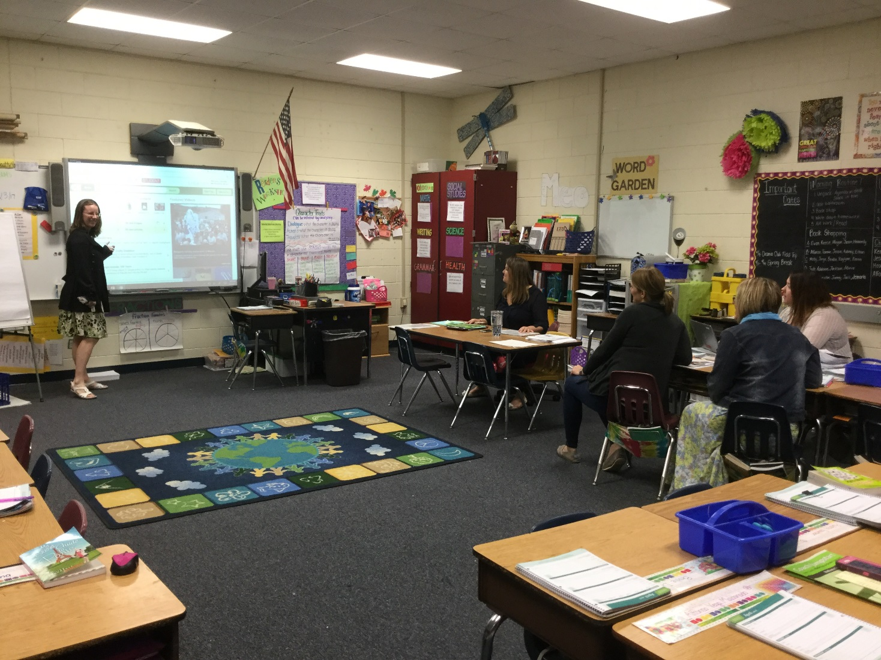
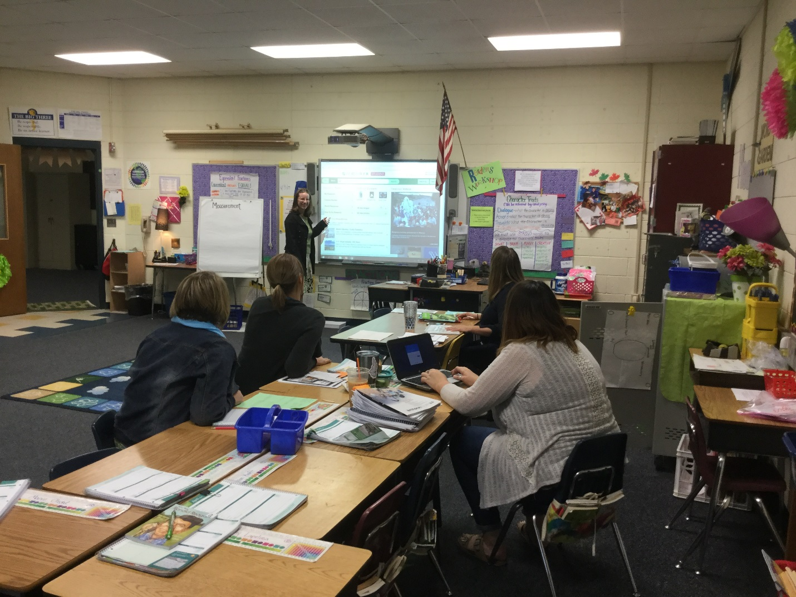

(6) Reflection
It is really hard to draw any definitive conclusions about how successful my professional development sessions were based on such few survey responses. No one sounded like they hated my presentations or didn’t benefit from them at all. I was hoping the respondents who ranked my presentation’s relevance to the classroom as a ‘3’ would have given some comments regarding how I could have better tailored my presentation to connect with what they’re teaching in the classroom. After examining the survey results, I’m glad they found the science resources useful, but I know that the public library doesn’t have any math resources, so I would have to find other websites to share that teach math. Overall, I feel like this professional development was beneficial to most teachers involved.
One of the biggest lessons I learned from these presentations is how limited the teachers’ time is. I had to go during their planning periods as no one was willing to stay any extra before or after school. After I talked about the resources that were specific to their students’ upcoming research projects, I had hoped to continue on with the rest of my powerpoint that gave an overview of other public library resources, but the third grade team told me to email it instead and I could tell that the 4th and 5th grade team really wanted to move on. For my work at the public library, I tried to reach out to another elementary school to promote ONE access resources there with teachers and parents. I gave a short 10 minute presentation at a staff meeting one afternoon, which the media specialist did not appreciate as she felt all that she had covered all that information herself well enough. I asked if I could present at a PTO meeting to speak with parents, but she thought a video that she could share through the parent newsletter and email to teachers would be more effective. I’m in the process of making a video with step-by-step instructions for downloading eBooks and digital resources through the public library, but it’s taking me hours. At least it would be something I could send out year after year to promote these resources so all of the time might pay off.
Based on these experiences, I would say my professional development at Cornelius Elementary School was much more rewarding and effective because I emailed the teachers to find out about specific research projects that would help them meet curriculum goals that they were planning to meet in their classes anyway. One thing that could have made it even better was if I had Chromebooks or iPads to give to each teacher so that they could go through the steps of accessing and searching in each database as I presented it. Again, I was concerned that time might be a factor, which is why I didn’t attempt this. After the program, I did email the presentation and the specific research notes I had for each grade level to each teacher. I never heard if they appreciated it or found it useful, but at least it was something they could refer back to.
Since my presentations were in such small groups, there were quite a few questions and comments throughout my presentations, which made me think that there were at least a couple teachers from each group who found it beneficial. Or sometimes they’d ask me to talk slower or go over the steps again so they could write down everything I was saying. Maybe I should have printed off the PowerPoint presentation for them to take notes on as I was talking instead of just emailing it to them. One of the biggest conversations I generated was with the 4th grade team, who was more interested in accessing the eBooks we had available. They first wanted to know about tips I had for making it easier for kids to read on a screen as opposed to a book, so I talked about being able to bookmark pages, type notes, adjust screen brightness, and change the magnification of the page. Then they got really excited about the possibility of downloading or streaming a class set of the same book on their class set of chromebooks. I had to actually ask a supervisor at the public library if this is something they’d be able to do. Unfortunately, Hoopla, the vendor that particular book is provided through, requires a parent email to login and sometimes there are daily download limits based on how quickly the system’s allocated funding for Hoopla has been used. While it doesn’t look like this class will be downloading a class set of books from the public library, at least the teachers were made aware of this option to possibly explore for at least some students in the future.
Overall, given the limited time constraints I was under, I feel like these professional development session were about the best I could offer to these teachers about public library resources. I would imagine more students and teachers are taking advantage of these resources than the survey results show.

