Unit Plan for LIS 654 Collaborative Subject Unit
_____________________________________________________________________
Student Names: Mary Old, Justin Miller, Megan Northcote, Madison Snow

Unit Plan Title/Topic: Earth in the Universe: Where in the world are we?
- An advocacy unit: In celebration of Music In Our Schools Month, Youth Art Month, National Poetry Month and School Library Month, all occurring between March and April
Subject Areas for Collaboration: Science, Art, Music
Grade Level: Third Grade
Collaboration Continuum: Intensive
Type of Library Schedule: Fixed
Teacher Roles: Librarian, Art Teacher, Music Teacher, Lead 3rd Grade Teacher
Estimated Lesson time: One month, four lessons that are 55 minutes each

Scenario:
Previous knowledge/exposure: Prior to this unit, students worked with their classroom teachers to conduct oreo activities which modeled moon phases and watched a video illustrating the solar system planet rotation. Students then completed a kinesthetic exercise by collaborating with each other to place the planet they were holding in the correct order with other planets held by their classmates.

Teacher roles: In lesson 1, the Teacher Librarian (TL) will be co-teaching with the third grade classroom teacher during our Wonder and Investigate stage. This collaboration and teamwork should allow for the two teachers to reach each student at least once while they research a celestial body.
In lesson 2, the students will use their research to create “foldable” interplanetary travel brochures. Students will work on the textual portion of the travel brochures with the librarian, then complete the visual component with the art teacher. Throughout the process, students will use a rating scale designed by both the TL and art teacher.
In lesson 3, the TL will build off the music teacher’s prior instruction regarding elements of poetry in songs and spend some time reviewing and identifying poetic elements in space poems. The students will then write their own poem about their celestial body, being sure to follow the criteria in the rubric and adhering to advice given in their mini conferences.
In lesson 4, the TL will show students how to enhance their poems using the website Animoto. With guidance from the TL, art teacher and music teacher, students will use Animoto to enhance their poems by adding music and images, creating a video that elevates their poem.

Culminating event: The unit will culminate during a PTA Resource Advocacy night. Select students will read their solar system poems in a poetry slam during open mic time. In between performances, Animoto presentations will be projected for viewing. The music teacher will make drums, maracas and other musical instruments available for students to keep rhythm during the Animoto presentations. All poetry will be on display for independent reading. Students will hand out copies of their travel brochures to visitors and pretend that they are travel agents advertising vacations to their chosen celestial bodies. Various space oriented craft activities, organized by the art teacher, will be available. The library will be open for checkout on related books, and LibGuides listing websites and books will be handed out (See Appendix 8). Third grade teachers will dress up as different planets, and visitors who can guess their planetary name will win a prize.

Individual Lesson Plan Titles:
Lesson 1: Investigating our Solar System (Wonder and Investigate)
Lesson 2: Constructing interplanetary travel brochures (Construct)
Lesson 3: Interpreting our solar system through poetry (Construct and Express)
Lesson 4: Enhancing planetary poems with Animoto (Express, Share and Reflect)

Essential Question:
To facilitate critical thinking, the TL will prompt students with the following guiding question throughout the unit: How do the earth, moon and sun affect each other and relate to the rest of the solar system?

Standards for the 21st Century Learner:
Standards for the 21st-Century Learner:
- 3.4 Self-Assessment Strategies 3.4.2 Assess the quality and effectiveness of the learning product. (Rubric for lesson 2 travel brochures)
- 4.1.8 Skills Use creative and artistic formats to express personal learning (lesson 3 for creating poems)
- 2.1.6 Skills Use the writing process, media and visual literacy, and technology skills to create products that express new understandings (lesson 4 - digitizing the poem and adding music and a visual)
- 3.2 Disposition In Action 3.2.1 Demonstrate leadership and confidence by presenting ideas to others in both formal and informal situations. (Thinking this would fall under lesson 2 as they share their brochures as well as lesson 3 as students use Animoto.)

Common Core State Standards and/or Other State Standards:

Standards for librarian focus:
1. Science: NCES 3.E.1 Recognize the major components and patterns observed in the earth/moon/sun system
- 3.E.1.1 Recognize that the earth is part of a system called the solar system that includes the sun (a star), planets, and many moons and the earth is the third planet from the sun in our solar system
2. English Language Arts: CCSS. ELA-Literacy.RI.3.3: Describe the relationship between a series of historical events, scientific ideas or concepts, or steps in technical procedures in a text, using language that pertains to times, sequence and cause/effect.
3. English Language Arts: CCSS.ELA-LITERACY.RF.3.4.B: Read grade-level prose and poetry orally with accuracy, appropriate rate, and expression on successive readings.

Standards for resource teacher focus:
1. Music: NCES K.CR.1.2: Recognize the relationships between music and concepts from other areas.
2. Art: NCES K.CX.2: Understand the interdisciplinary connections and life applications of the visual arts.

Student Learning Objectives: (Assigned to lessons below)
- Follow the steps of the inquiry process to study the Earth, moon, and solar system. (Lesson 1)
- Explore, demonstrate, communicate, apply and evaluate knowledge of the scientific concepts of Earth and space systems, their patterns and sequences. (Lessons 1 and 2)
- Produce an original work that demonstrates an understanding of the connections and applications of Earth and space systems using visuals. (Lesson 2)
- Investigate the components of poetry and how they relate to musical properties, then apply that understanding to the creation of poetry and songs about celestial bodies. (Lesson 3)
- Explore, demonstrate, apply and evaluate knowledge of the properties of planets using multimedia, such as text, sound and visuals. (Lesson 4)

Instructional Plan

Lesson 1: (Wonder and Investigate)
Created by Justin Miller

Lesson 1: Student Learning Objectives:
- Follow the steps of the inquiry process to study the Earth, moon, and solar system.
- Explore, apply, and evaluate knowledge of the scientific concepts of Earth and space systems, their patterns and sequences.

Lesson 1: Resources Students Will Use:
- Student reflective research journals, pencils, computers, nonfiction materials
- Student self-checklist (See Appendix 2)
- Student exit ticket (See Appendix 3)

Lesson 1: Resources Instructors Will Use:
- Computer with SMART Board capabilities
- List of possible research questions

Lesson 1: Instruction/Activities:
- Direct Instruction: (5 minutes) The Teacher Librarian (TL) will begin the lesson with satellite photos taken by NASA as a visual activator. (See Appendix 1) Students will discuss their background knowledge of the solar system and ponder initial questions.
  - Sample questions could include: What is Earth’s place in the Solar System? How does Earth’s physical characteristics and motion compare to other bodies in the Solar System? Why is our solar system a system? What adaptations would you have to make to live on another planet?
- Modeling and guided practice: (5 minutes) The TL will model research methods using a few books/nonfiction materials and interactive sites that are included on the library website. The TL will focus on parts of a nonfiction book that should be utilized by the reader such as the Table of Contents, Glossary, picture captions, and headings. The TL will also visit one interactive website and review a few research techniques. The TL will remind students the expectations for citing their sources for each book or site that they use. The TL will then explain the expectations for today’s research project. Students are to choose one celestial body and focus their research on this one celestial body. The TL will share the student checklist (See Appendix 2) with the students. The checklist will include several questions that should be answered during their research. This information as well as other facts will be recorded in the student’s reflective journal.
- Independent practice: (35 minutes) Students will answer the essential questions included on the checklist about their chosen celestial body. Students will then record their findings/concerns in reflective journals. Student checklists will be completed during the research process. The teacher and TL will have mini conferences with the students as they are working on their research and together will review progress using the student's checklist.
- Sharing and reflecting: (10 minutes) Students will complete their exit ticket (See Appendix 3) which will include one interesting fact that they learned about their celestial body. Students will then have time to share out their fact with their classmates.

Lesson 1: Final Student Products: Student checklist, student exit ticket, reflective journal entry

Lesson 1: Assessments:
- Tool/Product: A student self-checklist listing the components and facts that the students should gather about their topic.
- Process - Student Self-Questioning: the checklist will be completed by the student by the end of the lesson. The checklist will check for factual information,
(ie. name, position in solar system, rotation on axis, size, temperature and atmosphere, composition, orbit, rings, moons, how it was discovered) as well as evidence of critical thinking, (could a human survive?, what obstacles prevent landings?, how does it compare to earth’s environment?, what does the planet look like from earth?).

The checklist will also set a minimum number of websites the students must consult. The teacher and librarian will have mini conferences with the students as they are working on their research. Making a plan to meet with each student provides them an opportunity to articulate what they are thinking and provides the educator with those coaching moments where students can be guided to construct their own understandings (Maniotes, 2013). The students will also complete an exit ticket (See Appendix 3) listing one interesting fact they learned about their celestial body and what concerns they may have with the upcoming travel brochure. Students will hopefully have time to share their one fact with classmates.

Lesson 2: (Construct)
Created by Mary Old

Lesson 2: Student Learning Objectives:
- Demonstrate and communicate knowledge of the scientific concepts of Earth and space systems, their patterns and sequences.
- Produce an original work that demonstrates an understanding of the connections and applications of Earth and space systems using visuals.

Lesson 2: Resources Students Will Use:
- Foldable travel brochure template (See Appendix 5), construction paper, writing utensils, ruler, colored pencils, glue, reflective journals
- Self-rating scale (See Appendix 4)
Lesson 2: Resources Instructors Will Use:
- Word wall
- Sample travel brochures

Lesson 2: Instruction/Activities:
- Direct Instruction (5 minutes)
  - Anticipation set: The TL will lead a discussion in the use of travel companies and travel guides by asking the following questions:
    - “If you wanted to learn more about an exotic or unusual destination for a vacation, who could you speak to?”
    - “What materials do travel agents have that could help you learn more without ever leaving your hometown?”
    - “What travel destinations may be possible in the distant future?”
    - “What could a travel agent say or do to convince to visit a place?”
The TL will explain how a persuasive tone can be used when trying to convince a reader of something. Students will practice saying persuasive statements that relate to their own desires and needs. The TL will nudge the students’ discussions to include keywords such as, “should, must, necessary, worthwhile and benefit.”

- Modeling and guided practice: (10 minutes) The TL will model guiding questions that will form the content of the travel brochures. Questioning dealing with celestial content data will include:
  - The atmospheric conditions:
    - “On your travel destination what is the weather like? (so that I know what to pack); Are there oceans? (should I bring a swimsuit); Do I need to bring extra sunscreen? (because it’s incredibly sunny); Should I bring extra water? (because it’s really hot); Should I bring a down jacket? (because it’s really cold)”
  - The physical features:
    - “What are the local attractions? (these should real natural formations or places that can be found on your planet)”
  - The housing:
    - “Where can people stay? Will this will require a map or diagram of your celestial body? How will this habitat provide protection from the elements?”
  - The food:
    - “What can people eat? (based on what you know about your site)”
Students will refer to a word wall listing vocabulary from their Solar System Science unit when formulating responses to the discussion.

- Independent practice: (40 minutes) Students will connect their new knowledge with personal interests by pursuing two or more of the following critical thinking activities:
  - Design a suit to survive visitation of your celestial body.
  - Create a menu of foods that you could possibly grow on your celestial body to serve guests.
  - Design a spacecraft that could survive the atmospheric entry to your celestial body.
  - Design a resort that provides a habitable environment on your chosen celestial body.
Students will incorporate two or more of these designs into their travel brochure, along with a description of their celestial body (atmosphere, physical features, temperature, distance from sun, size, color, etc.). Students will work on the textual portion of the travel brochures with the librarian, then complete the visual component with the art teacher. In the art class, students will be required to incorporate at least three visuals into their travel brochure.

Assessing in the “intervention zone:” The TL and art teacher will collaborate to create a student centered rating scale for self-assessment and feedback. Students will refer to the criteria listed in their rating scale to assess their progress while working. As students work, the TL will observe student progress and add written feedback on the rating scale, as well as offer assistance as needed. Students will bring their rating scales to the art room to create the visuals for their travel brochure. Completed travel brochures will be displayed in the library. (Maniotes, 2010)

- Sharing and reflecting: During the culminating PTA night, students will pretend to be a Travel Agent and present their celestial body's finest features to visitors. Citing evidence of food production, safe travel vessels, livable quarters or specially designed garments, students will try to convince others to visit.

Lesson 2: Final Student Products: Foldable interplanetary travel brochure

Lesson 2: Assessments:
- Tool/Product: A student self-rating scale listing the required components of the travel brochure will be created by the librarian and music teacher.
  - Process: The students will first rate themselves, followed by the teacher’s response. Criteria will include:
    - Content: Evidence of description of their celestial body; discussion of human survival based on 2 or more facts about the celestial body; persuasive tone; grammar and spelling
    - Design and layout: incorporates a minimum of 3 colorful photos, graphics or drawings and text.
- Student self-questioning: Students will think critically about how well they prepared for the survival of visitors to their celestial body. At the end of the lesson, they will complete a reflection portion of the rating scale. Here they will reflect on how creatively they integrated the facts about their celestial body with their own design plans (See Appendix 3).

Lesson 3: (Construct and Express)
Created by Megan Northcote

Lesson 3: Student Learning Objectives:
- Investigate the components of poetry and how they relate to musical properties, then apply that understanding to the creation of poetry and songs about celestial bodies.

Lesson 3: Resources Students Will Use:
- Computer with word processor, reflective journals, interplanetary brochures
Lesson 3: Resources Instructors Will Use:
- SMART Board, examples of space poems and songs (See Appendix 6)

Lesson 3: Instruction/Activities: Teacher Librarian-Music teacher:
- Direct Instruction (10 minutes): Prior to the lesson, the music teacher will have guided the children in singing songs about space and identifying elements of the song to the children (rhyme, rhythm, repetition, breaks, etc.). See Appendix 6 for two examples (Stars! Planets! Action! and The Family of the Sun!). She will discuss the following vocabulary terms and identify them in them songs, if applicable: rhythm, meter, line breaks, repetition, melody, and rhyme.

During the lesson, the teacher librarian will lead students in analyzing poetry (See Appendix 6) about the solar system (as well as other poems), while discussing poetry types (free verse, limerick, quatrain, limerick, cinquain, etc.) and reviewing poetry structure (rhythm, meter, line breaks, repetition, melody and rhyme). The TL will also discuss the language of poetry, showing examples of how different poems can convey imagery through specific word choice, especially through description and detail.

- Modeling and guided practice: (10 minutes) The teacher librarian will project specific examples of poems (See Appendix 6) on the SMART Board (not necessarily related to space) and point out a couple key features in each. As a group, the librarian will then ask the students to identify some of these elements in a few more poems.
  - Possible questions to ask might include: What format is this poem written in? How do you know? Who can find me an example of a rhyming couplet in this poem? What words convey imagery or a specific image you can vividly see in your mind? Can someone tell me the rhyme scheme (ABAB, etc.) for this poem?

- Independent practice: (25-30 minutes), students will write their own poem, incorporating these techniques, based around the celestial body they researched for their interplanetary brochures. Students will consult their reflective journals and interplanetary brochures from lesson 1 and 2 to pull a fact or two to creatively incorporate into their poems. Poems will be typed on a word processor so that they can be shared digitally with all collaborating teachers, and be easily posted on the library’s web page when completed. As students are working, the music teacher and TL will be walking around and conducting mini conferences to make sure the students are working through any potential roadblocks.

- Sharing and reflecting: (5-10 minutes) During the last few minutes of class, students will be given the opportunity to share their poems with their classmates. They can stand at the front of the class or at their seat and read their poem aloud. Other classmates will be allowed to comment on the poem by raising their hand through constructive verbal feedback.

Lesson 3: Final Student Products:
- Each student will create their own poem about their celestial body (See Appendix 7)

Lesson 3: Assessments: While students are typing their poems, the music teacher and librarian will be walking around, conducting mini conferences with the students regarding their progress in crafting their own poem and informally making sure they are following the required components in the rubric.
- Tool/Product: The librarian and music teacher will devise a teacher rubric (See Appendix 7) for assessing the components of the space poem. The rubric will assess the following areas: idea/content, structure and conventions, organization, use of poetic language, voice, and creativity each on a four point scale for a total of 24 points.

- Process - Student self-questioning: During the student share and reflect period, students will revisit their journals to record their reactions to this stage of the inquiry journey - construct and express. They can write about the challenges they had in writing their poems, what they liked most about their finished poem, and what they wish they could change or do differently next time. They can also reflect on what images or songs they think might best accompany their poem in preparation for lesson 4.

Lesson 4: (Express, Share and Reflect)
Created by Madison Snow

Lesson 4: Student Learning Objectives:
- Explore, demonstrate, apply and evaluate knowledge of the properties of planets using multimedia, such as text, sound and visuals.

Lesson 4: Resources Students Will Use:
- Computers, poems written previously in Lesson 3, reflective journals.

Lesson 4: Resources Instructors Will Use:
- The TL, Music Teacher, Art Teacher will use a computer with SMART board technology.

Lesson 4: Instruction/Activities:

- Direct Instruction (10 minutes): The teacher librarian will introduce students to the website Animoto. The TL will give students a basic overview of the website, how it works and explain what their goals should be when enhancing their own poems.

This software was chosen specifically so students have opportunities to connect their personal, social, and cultural understandings, through art and music, to the formal concepts and ideas under study (“Third Space”) (Maniotes, 2013). Using Animoto allows for the “redefinition” of the students’ task, according to the SAMR model, inspiring students to create something entirely new that would be impossible without technology (Oxnevad, 2013). Students will use their existing original poems will serve as the basis of the project but will be completely transformed by their incorporation and enhancement using Animoto.

Why use Animoto?:
  - Educator account: This keeps the students' identities private, and only people who are part of the account can see the videos, unless the students choose to share the link. The educator account also allows access to advanced options for free.
  - Images: Animoto's extensive collection of images is arranged into helpful categories. There is also the option to access one's own images at photo-sharing sites such as Flickr, Facebook, and Picasa.
  - Music: Animoto's collection encompasses diverse genres. Students can also upload music, and the 30-second limit ensures that any use of copyrighted music would fall under fair use.
  - Remix: The Animoto software remixes the video for users. Once the order of slides is set, the Web site takes over. Students can remix until the visual presentation meets their approval (Metzger, 2011).

- Modeling and guided practice (15 minutes): In the computer lab, the teacher librarian will collaborate with the music and art teacher to help the students integrate music and a visual image(s) into their poem. The librarian, working with the music and art teacher, will showcase how to use Animoto by working to enhance a sample poem. First, the the TL will read aloud the sample poem so the students are familiar with its subject and content. Then, the TL (working with input from the students) will add media to the poem in order to show them how to use the technology. As the TL works, she will ask the students questions to increase their interest and draw their attention to the variety of options Animoto will give them.
  - Possible questions might include: How does adding pictures make the poem more interesting? What pictures can be included that will directly relate back to the poem? What kind of music could we use to mirror the mood of the poem?

- Independent practice (20 minutes): After becoming familiar with Animoto, the students will work on their own to combine their poems with media (pictures, music, etc.) using Animoto. As the students work, the TL and assisting art and music teachers will circulate throughout the room to make sure the students are utilizing the website properly, answer any questions and guide the students as they make their media selections.

- Sharing and reflecting (10 minutes): Students will spend some time looking back through their reflective journals to reflect back on all that they have learned throughout this unit. While no formal assessment will be given of this reflection time, the TL will guide the students’ reflection by prompting them with questions before they review their reflective journals.
  - Possible questions might include: What is the most interesting thing you learned in this unit? What was the most surprising thing you learned in this unit? What was your favorite lesson in this unit and why? What was your least favorite lesson in this unit and why?

While the students will not have the opportunity to share their Animoto creations in class, the TL will later post the completed Animoto presentations to the library’s webpage. Students can access the library’s website in school or at home to view their own or other students’ creations. The Animoto version of their poems will also be shared at the PTA event for parents to see.

Lesson 4: Final Student Products: Animoto enhanced versions of their poems, complete with music and pictures.

Lesson 4: Assessments:
- Tool/Product:The librarian and music teacher will design a teacher rating scale for assessing the digitization of the poem, incorporation of a visual element and song overlay (See Appendix 9).

- Process: Student Self-Questioning

Students will revisit their reflective journals and reflect on the the outcome of their inquiry journey. Because the students have kept journals throughout the unit, they are able to track their progress and can see how they have evolved through their understanding of concepts, themes, as well as formed their own perspective on the topic. Tracking the journey through journals and logs helps students reflect and persist through inquiry because they have a visual documentation of their understanding and learning through the process. This is absolutely worth the time because it will help students heighten their awareness of what helped them reach a higher level of understanding in inquiry. Once they have reflected on what helped them, they are more likely to use these strategies in the future (Maniotes, 2013).

Strategies for differentiation:
Lesson 1: For students who are performing below grade level, a modified checklist will be provided. These students will be asked to only focus on one nonfiction book and one approved website instead of the required two. For students that are performing above grade level expectations, again a modified checklist will be provided asking for those students to use more than the two required books and approved websites.
Lesson 2: For students with learning disabilities, a modified rating scale will be provided. These students will be asked to create only one original design (survival suit, home, menu, spacecraft). Students with limited dexterity will not be required to draw their three images. These students will be allowed to combine images from magazines, or combine print images from the internet.
Lesson 3: Students who have different learning challenges will complete the poem assignment using a modified rubric. Instead of writing a poem that fits a particular poem format or incorporates poetry elements (rhythm, rhyme, descriptive language, etc.), the student can simply be expected to write a few lines that relate to their celestial body, but which may not be as poetic sounding in nature. The teacher librarian or music teacher can then work one on one with the student to see how they could infuse some poetic elements into their writing as needed. Assistive technologies could be used to allow the student to type their poem with an enlarged keyboard or with screen filters, etc. Or the student could simply hand write their poem or dictate their poem to the teacher or librarian, depending on their Individual Education Plan (IEP).
Lesson 4: For students who perform below grade level or have difficulty using technology, accommodations will be made by partnering them with a high performing classmate. Instead of completing separate Animoto videos with their two poems, the students will work as a team to animate one of the students’ poems. Using the teacher rating scale, the TL, art teacher and music teacher will evaluate the pair’s video together and use a modified rating scale to analyze their teamwork and how they cooperated during the project.

References:
Maniotes, L. K. (2010). Teaching in the Zone: Formative Assessments for Critical Thinking. Library Media Connection, 29(1), 36-39.

Maniotes, L. (2013). Stick-to-itiveness: Three Strategies to Achieve Persistence through Inquiry. School Library Monthly, 30(2), 9-11.

Maniotes, L., & Kuhlthau, C. (2014). MAKING THE SHIFT. Knowledge Quest, 43(2), 8-17.

Metzger, K. C. (2011). Poetry goes viral. Voice of Youth Advocates, 34(1), 23.

Oxnevad, S. (2013). Using SAMR to Teach Above the Line. Retrieved from http://gettingsmart.com/2013/07/using-samr-to-teach-above-the-line/.

Stubeck, C. J. (2015). ENABLING INQUIRY LEARNING IN FIXED-SCHEDULE LIBRARIES. Knowledge Quest, 43(3), 28-34.

Appendixes:

Appendix 1: Lesson 1 Visual Activator

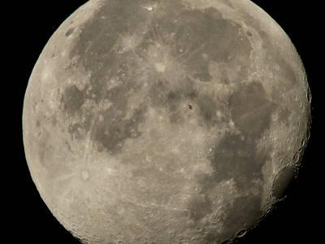
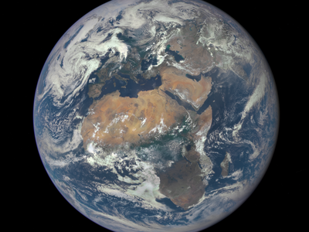
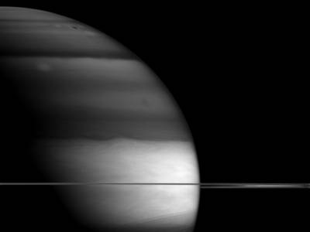
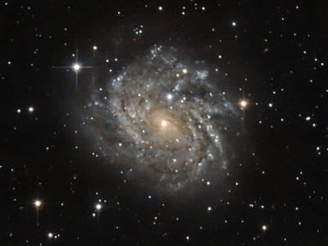

Appendix 2: Lesson 1 Student Self-Checklist
Created by Justin Miller
Name: _______________________ Homeroom Teacher: ____________________
Did I choose one celestial body to focus my research on? | Yes | No | Comment
Did I locate the average temperature for my celestial body? | Yes | No | Comment
Did I determine the position of celestial body in the Solar System? | Yes | No | Comment
Did I determine the rotation of my celestial body? (the length of a day compared to Earth) | Yes | No | Comment
Did I determine the orbit of my celestial body? (the length of time for 1 year compared to earth) | Yes | No | Comment
Did I locate information about the discovery of my celestial body? | Yes | No | Comment
Did include at least 3 fun facts about my celestial body? | Yes | No | Comment
Did use and cite at least 2 nonfiction sources of information | Yes | No | Comment
Did I use and cite at least two approved websites? | Yes | No | Comment
Appendix 3: Lesson 1 Exit Ticket
Created by Justin Miller

Name: | Homeroom Teacher:
Please list one interesting fact that you learned about your celestial body. | Fact:
What concerns or questions do you have with the upcoming travel brochure activity? | Concern or Questions:

Appendix 4: Lesson 2 Travel Brochure Rating Scale
Created by Mary Old
Criteria Rating Teacher feedback
Low Average High
1.Human Survival: ________________
Did you design 2 or ________________
more of the following? ____ ____ ____ ________________
(Survival suit, menu, 0 1 2+ ________________
Spacecraft, housing)

2.Seven descriptions
of your celestial body:
Did you analyze the ________________
atmosphere, physical ____ ____ ____ ________________
features, temperature, 0-3 4-6 7 ________________
distance from sun, ________________
orbiting bodies,
size and color?

3.Persuasive tone:
Were your reasons to ________________
visit your celestial body ____ ____ ____ ________________
convincing? ________________

4.Grammar and
spelling: Did you ________________
use correctly ____ ____ ____ ________________
spelled scientific ________________
terms from the word ________________
wall?

5.Visuals: Did you create ____ ____ ____ ________________
at least 3 colorful and 0 1-2 3+ ________________
detailed drawings?

Reflection: (To be completed at the end of the project)
How did you creatively develop your design plans to incorporate the facts about your celestial body?______________________________________________________________________
___________________________________________________________________________
___________________________________________________________________________
Appendix 5: Lesson 2 Travel Brochure Template
(From the NASA Space School Musical Activity Guide)
Front view: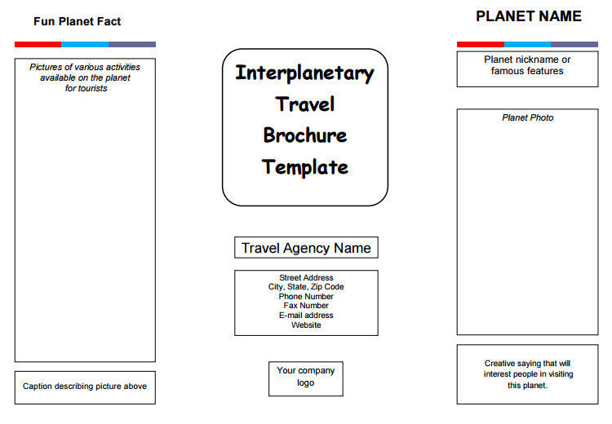Rear view:
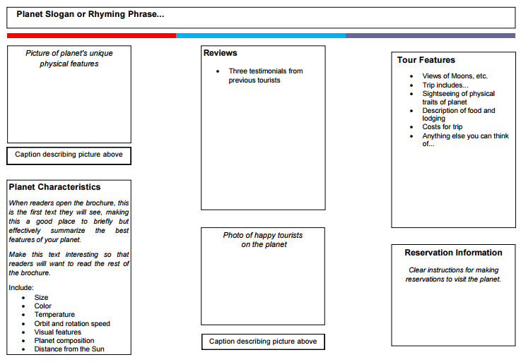

Appendix 6:
Examples of space songs:
http://www.naturallyeducational.com/2011/08/outer-space-songs-for-preschool-through-elementary-school/

Stars! Planets! Action!
Sung to: “London Bridge”

The planets
spin around the sun,
Around the sun, Around the sun.
The planets spin around the sun,
We live on earth!

The sun is found in the middle,
In the middle, In the middle.
The sun is found in the middle,
It keeps us warm!

The stars are twinkling far away,
Far away, far away.
the stars are twinkling far away,
Now make a wish

The Family of the Sun (Ages 5+)
Sung to: “Farmer in the Dell”

REFRAIN
The family of the Sun,
The family of the Sun,
Here are eight planets in
the family of the Sun.
Mercury is hot,
And Mercury is small.
Mercury has no atmosphere;
It’s just a rocky ball.

REFRAIN

Venus has thick clouds
That hide what is below.
The air is foul; the ground is hot.
It rotates very slow.

REFRAIN

We love the Earth our home,
Its oceans and its trees.
We eat its food; we breathe its air,
So no pollution, please.

REFRAIN

Mars is very red.
It’s also dry and cold.
Some day you might visit Mars
If you are really bold.

REFRAIN

Great Jupiter is big.
We’ve studied it a lot.
We found that it has lots of moons,
And a big, red spot.

REFRAIN

Saturn has great rings.
We wondered what they were.
Now we know they’re icy rocks
Which we saw as a blur.

REFRAIN

Uranus is far.
It’s cold and greenish-blue.
We found it rotates sideways,
And it has a lot of moons.

REFRAIN

Neptune has a spot;
A stormy patch of blue.
The planet has a lot of clouds
And rings around it, too.

REFRAIN

Examples of space poems:

Solar System
(to the tune of "Twinkle, Twinkle, Little Star)
Twinkle, twinkle, little star,
Oh so bright and oh so far.
In the sky, a tiny dot.
Glowing gas that's very hot!
Twinkle, twinkle, little star,
Oh so bright and oh so far.
Beaming, beaming, gleaming moon,
Like a giant white balloon,
Round and round the Earth you spin,
Through the month, new shapes you're in.
Beaming, beaming, gleaming moon,
Like a giant white balloon.
Glowing, glowing, red-hot sun.
Shining light on everyone.
Earth goes round you once a year.
You're a star with atmosphere!
Glowing, glowing, red-hot sun,
Shining light on everyone.
http://www.canteach.ca/elementary/songspoems34.html

Moon
Are you lonely, Moon?
You giant white balloon!
You have no water, wind or air.
No wonder, nothing lives up their.
You can't grow trees or flowers or grass.
Your soil is only rocks and glass.
Even your light is not your own.
Instead it's from the sun that's shone.
Your gravity is weak, I hear.
You really have no atmosphere.
But don't be sad, Moon, please don't cry.
For I still love you in the sky.
- By Meish Goldish
http://www.canteach.ca/elementary/songspoems34.html

my jupiter
the moons of jupiter can be found in her eyes
they shine brightly
even the sun
blinks her eyes
in jealousy
the pensive green-eyed monster
http://hellopoetry.com/words/21879/jupiter/poems/

Earth Poem

It's the spinning,
Little rock,
Flying through the air,
Third planet from the big bright sun,
A place we all do share!

Only planet with known life,
From birds, to bears, and bees...
So many types of living things,
From forests,
To blue seas...
Yes we all,
Share this rock,
The planet we all roam,
Let's care for our great mother Earth
The place we all call home...

http://sciencepoems.net/sciencepoems/earth.aspx#.VxOui_krLIU
Mars Poem

Martians are coming,
They're coming right here,
They're from the 4th planet,
Oh-my and oh-dear!
Their planet looks reddish,
From iron oxide,
What should we do?
Shall we run, fight, or hide?
Their planet's named Mars,
Half of Earth’s size,
But the Martians are giant,
Have lasers for eyes!

Martians are here,
A fact we can’t hide,
They came in a spaceship,
A long, long, long ride!
But news is now out,
From Fiji to France,
Martians are friendly,
They came here to dance!

http://sciencepoems.net/sciencepoems/mars.aspx#.VxOuXfkrLIU

Appendix 7: Poetry Rubric, Lesson 3
Created by Megan Northcote

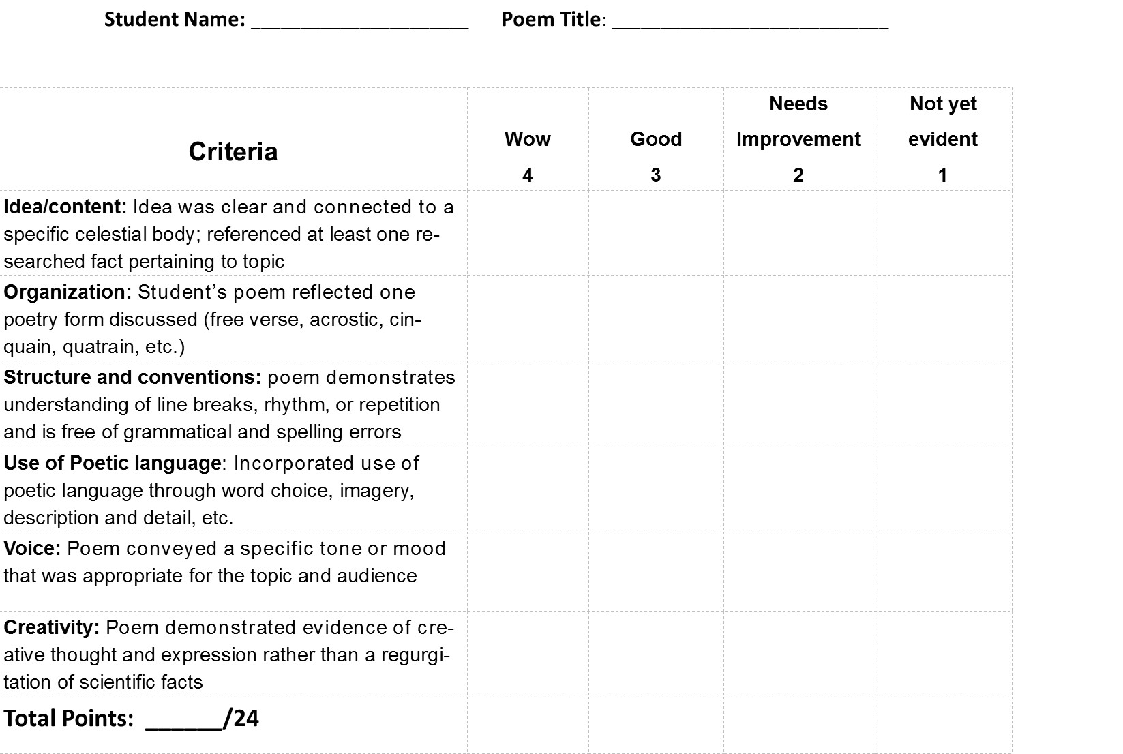

Appendix 8: PTA Night LibGuide
Created by Mary Old
Websites:
- BrainPop: Solar System video: http://www.brainpop.com/science/space/solarsystem/preview.weml
- NASA’s solar system simulator: http://space.jpl.nasa.gov/
- Kid’s Astronomy: http://www.kidsastronomy.com/solar_system.htm This site provides information about the solar system, including earth and its moon, and comets and asteroids. Easy to navigate. Grades 2-5
- A curation of interactive websites about the earth, moon and sun:
http://interactivesites.weebly.com/earth-moon-and-sun.html
- An interactive site that allows you to manipulate the seasons by changing the earth’s axis: http://janus.astro.umd.edu/astro/seasons/
- Songs about the solar system: http://www.songsforteaching.com/sciencesongs.htm
- A description of every type of celestial body: http://www.seasky.org/celestial-objects/planets.html
- Samples of poetry about the solar system: http://www.poetrysoup.com/poems/solar_system
http://www.canteach.ca/elementary/songspoems34.html
http://hellopoetry.com/words/
http://sciencepoems.net/sciencepoems/
Books:
- 1000 Facts About Space, by Pam Beasant
- 924 Elementary Problems and Answers in Solar System Astronomy, by J. Van Allen
- Amanda Visits the Planets, by Gina Ingoglia

The solar system book for kids: amazing pictures and fun facts about the solar system, space and the planets, by Michael Justin

Space Encyclopedia: A Tour of Our Solar System and Beyond (National

Geographic Kids), by David A. Aguilar
- The Children's Space Atlas : A Voyage of Discovery for Young Astronauts, by Robin Kerrod

Comets and Asteroids: Space Rocks (Our Solar System), by Greg Roza
- The Magic School Bus: Lost in the Solar System, by Joanna Cole
- Me and My Place in Space, by Joan Sweeney
- Comets, Stars, the Moon, and Mars: Space Poems and Paintings, by D. Florian

Appendix 9: Animoto Rating Scale
Created by Madison Snow

Criteria |  | Rating (Circle) |  | Teacher Feedback
 | Low (0-1) | Average (2-3) | High (4-5)
1. Visual Images
Did you include at least 2-3 images? | 0 1 | 2 3 | 4 5 | ________________________________________________________________________
Did your images relate back to your poem? | 0 1 | 2 3 | 4 5 | ________________________________________________________________________
Did your images help reflect the mood of your poem? | 0 1 | 2 3 | 4 5 | ________________________________________________________________________
2. Songs
Did you include a song? | 0 1 | 2 3 | 4 5 | ________________________________________________________________________
Did your song connect with and enhance the message of the poem? | 0 1 | 2 3 | 4 5 | ________________________________________________________________________
3. Overall
Did your Animoto video combine music, pictures and your poem in a fun and creative way? | 0 1 | 2 3 | 4 5 | ______________________________________________________________________________________________________________________________

