LIS 654 Social Studies Lesson Plan
Megan Northcote and Justin Miller
Spring 2016

Grade Level: Second Grade

Library Context (fixed, flexible, combination, individualized instruction, stand-alone lesson, lesson in a unit, multiple lessons in a unit): Flexible schedule. Stand-alone lessons building upon a second grade teacher’s unit focusing on Essential Standard 2.G.1 (Use geographic representations, terms and technology to process information from a spatial perspective.)

Collaboration Continuum (none, limited, moderate, extensive): Moderate

Content Topic: Map interpretation

Estimated Lesson Time: Two 35 minute lessons

STANDARDS FOR THE 21ST-CENTURY LEARNER

Skills Indicators:
- 3.1.4 Use technology and other information tools to organize and display knowledge and understanding in ways that others can view, use, and asses.

Disposition Indicators:

Responsibilities Indicators:
- AASL: 2.3.1 Connect understanding to the real world.

Self-Assessment Strategies Indicators:

Essential Question:
What are the essential elements that should be included in a real or fictional map? How can you read a map to determine how to get from one place to another?

Scenario:
- The TL’s (Teacher Librarians) will have moderate collaboration with the second grade team during their unit study focusing on Essential Standard 2.G.1 (Use geographic representations, terms and technology to process information from a spatial perspective.) There are a total of 4 objectives that the second grade team will cover during their unit of study. The TL’s will focus their two lessons on Objective 2.G.1.1 (Interpret maps of the school and community that contains symbols, legends and cardinal directions). These two lessons will act as follow up lessons that have occurred in the second grade classrooms. Prior to the lessons, students should be familiar with the key concepts as well as the vocabulary that the TL’s will be using during their lessons. The two lessons will occur in the school’s media center. The media center is equipped with Windows based computers that the students will use during one of the lessons to create their own digital map. Through follow up collaborations, the second grade team will be made aware of the TL’s lessons and how each class did, as well as the assessment results from each lesson.

Connection to state or local standards (list here relevant content standards):
- 2.G.1.1 Interpret maps of the school and community that contain symbols, legends and cardinal directions.
- 2.TT.1.3 Use technology tools to present data and information (multimedia, audio and visual recording, online collaboration tools, etc.).

- AASL: 2.3.1 Connect understanding to the real world.
- AASL: 3.1.4 Use technology and other information tools to organize and display knowledge and understanding in ways that others can view, use, and asses.

Overview: (include objectives here, i.e., what the learner will know or be able to do)
- Students will be able to identify basic elements of a map, including title, compass rose, and legend/key
- Students will be able to read a map using these elements to locate key buildings, symbols, and physical and human features
- Students will be able to create their own digital map using these basic elements

Final Product:
- Lesson 1- Activity sheet serving as an exit ticket
- Lesson 2- Completed digital map and completed teacher checklist
Library Lesson(s):
- Lesson 1- Map interpretation
- Lesson 2- Map interpretation and creation
Assessment Product:
- Lesson 1- Activity sheet serving as an exit ticket
- Lesson 2- Completed digital map and completed teacher checklist

Assessment Process:
In the first lesson, students will work in pairs to complete an activity sheet, which assesses their ability to read maps and to identify points of interest correctly. The teacher and teacher-librarian will be walking around during this independent practice time and asking the student pairs questions about their worksheet to assess that they are reading and interpreting the map correctly.

For the second lesson, the teacher and teacher-librarian will be holding mini conferences with each student, asking them questions about the digital map they are creating. This will help the teacher-librarian gauge age student’s level of understanding and help them fill out the checklist.

Student self-questioning:
Can I identify the compass rose on this map and label it correctly? Can I locate the map key/legend and use it to locate points of interest on a map? What direction is one place from another?

Instructional Plan Lesson 1
Resources students will use:
- Lesson 1-
Activity/Exit ticket
Pencil

Resources instructor will use:
- Lesson 1-
Visual Activators
Access to smart board computer
Very elementary paper map of a community

Instruction/Activities
Lesson 1:

Prior to class: The second grade classroom teacher will have taught the students about basic map elements (title, compass rose, legend/key, data, author, etc.)
Direct Instruction: (5 minutes)
- The librarian will spend some time reviewing elements of a map with the children by looking at different elements on different types of maps (see visual activators below). One image of a pirate map is missing a key. The other image of a make believe island is missing a compass rose.
Modeling and guided practice: (10 Minutes)
- The librarian will collaborate with the class on ideas for how to create a key for the pirate map (draw and write on the smartboard, image A=skull head, etc.) as well as a compass rose for the island (draw a compass rose on the board and ask the students which direction points north, south, east, and west using “Never Eat Soggy Waffles” as a mnemonic device).
- The librarian will then use the activators to review key vocabulary terms and map directions. (ex. In which direction is the snake located in comparison to the treasure?). She/he will ask the students to suggest a title for each map as well.

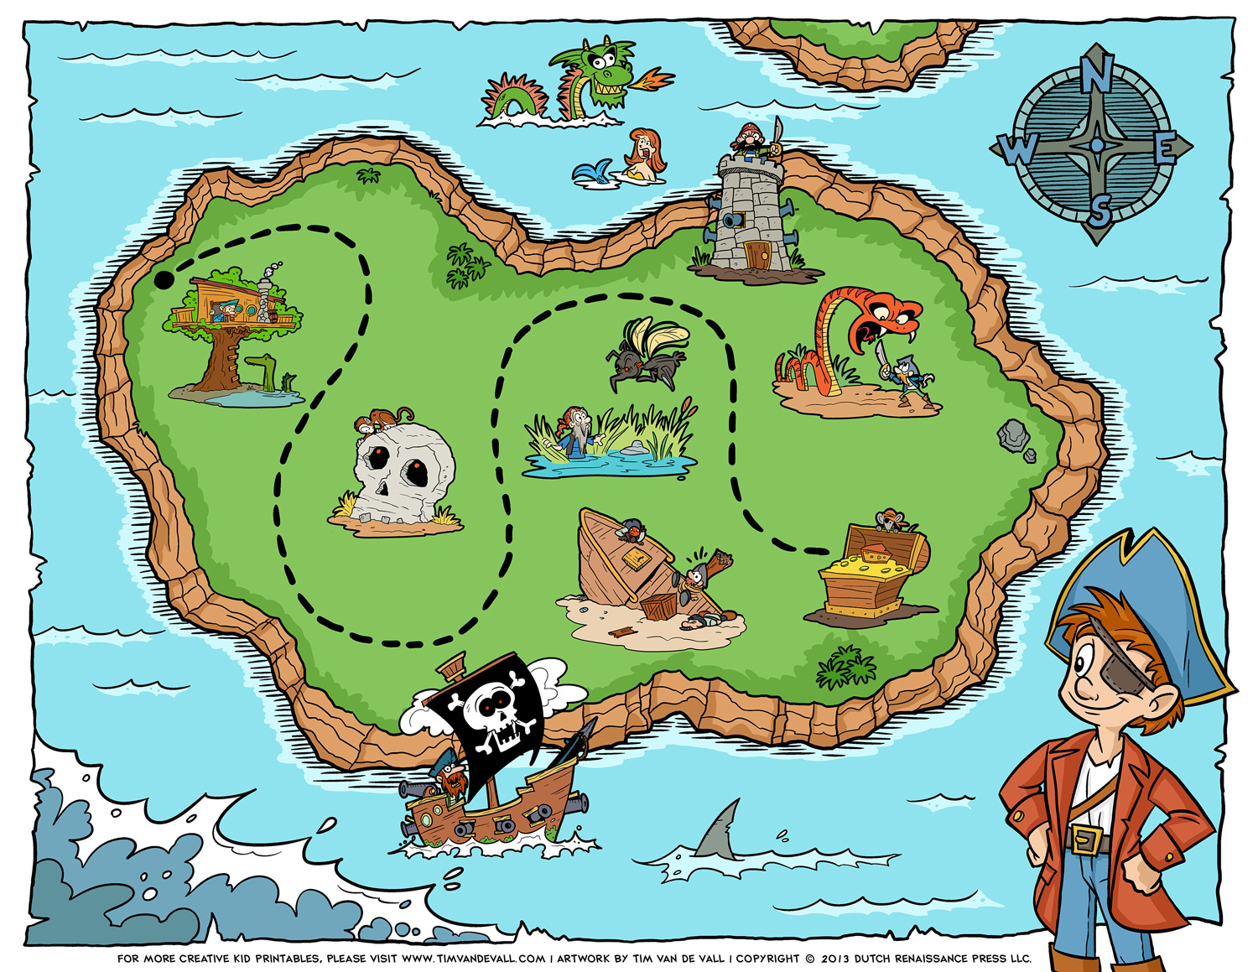
Visual Activators
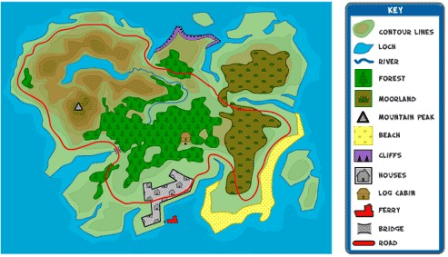

- The librarian will also display a map of a community (see below) and point to the real world features (roads, post office, school, cars, library, street names, etc.). The librarian will help the students connect this map to their real lives while explaining that maps can be used in stories to depict make believe places (pirate maps, fantasy islands) as well as real places (schools, homes, communities, cities, states, etc.).

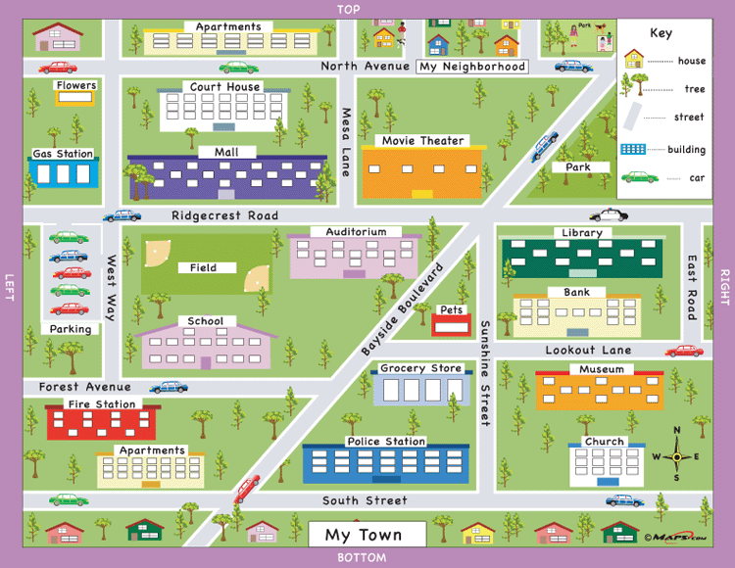
demo.maps101.com

Independent practice: (10 minutes)
- Students will pair up and be given a very simple map on an activity worksheet (see example at the bottom of this document.) Each student will work together to complete their own activity sheet. The sheet will serve as an exit ticket as it asks questions that easily assess whether or not students understand parts of a map and can comprehend how to read it. After labeling a compass rose, the activity sheet asks students to identify what direction (north, south, east, or west) one object is from another.

- Sharing and reflecting: (10 minutes) While the students are working, the librarian and teacher will be walking around to each pair and assessing their understanding by asking them questions to gauge their map reading skills. The teacher might say “point to the symbol for a cabin” or “how would I get from the cabin to the rowboat in three turns?”

- To assess their understanding of the real world, the librarian will ask each pair a similar question about this map to gauge their map reading skills. For example, if I’m starting at the fire station, what streets must I turn down in order to get to the movie theater?

Strategies for differentiation:

- For lower level learners, the librarian could modify the questions on the activity sheet to focus more on identifying points of interest using the legend. For example, point to the symbol that represents a house or circle a house that is on the west side.
- For more advanced learner, the librarian could make sure the activity sheet questions are more directional and analytical. For example, list two directional ways someone could get from the camper trailers to the row boats in three moves. As a final assessment piece, instead of giving the kids a real world map, the librarian could ask the kids to sketch a very simple map of something in their own lives. For example, draw a map showing how to get from your house to the neighborhood park. Because the librarian does not know how each student’s neighborhood is laid out, they would be looking more for signs of spatial awareness (trees, streets, and other houses would separate their house from the park, etc.).

Instructional Plan Lesson 2

Resources students will use:
- Lesson 2-
Access to window based computers for visiting: http://www.teacherled.com/resources/mapmaker/mapmakerload.html
Checklist for completed digital map for lesson 2

Resources instructor will use:
- Lesson 2-
Copy of the book Henry’s Map, written and illustrated by David Elliot
Checklist for completed digital map for lesson 2

Direct Instruction: (10 minutes)
- Lesson 2- Teacher Librarian (TL) will begin with a short review of yesterday’s lesson. The review will be student led with teacher prompts focusing on the key vocabulary words that were used in lesson 1. Discussion should focus on compass rose and its job on a map, a key and its job on a map, different types of maps, and what points of interest are on a map and how to directionally get from one point to another.
- The TL will then read the book Henry’s Map by David Elliot. In this book, Henry is a very particular sort of pig. "A place for everything and everything in its place," he always says. But when he looks out his window he is troubled. The farm is a mess! Henry is worried that nobody will be able to find anything in this mess. So he draws a map showing all the animals exactly where they belong. And Henry embarks on a journey through the farm, his friends tagging along as he creates his map: sheep in the woolshed, chickens in the coop, the horse in the stable. After the map is complete, Henry uses it to bring himself back home, where he is relieved to know that he is exactly where he belongs. A place for everything and everything in its place, indeed. After reading the book, as a whole we will discuss and compare Henry’s map with the illustration of the farm. TL will ask questions such as: What was included in Henry’s map, What is missing from Henry’s map, How would you make Henry’s map better.

Modeling and guided practice: (5 Minutes)
- Lesson 2- TL will now introduce the website that the students will use in creating their own digital map. This introduction will occur on the smart board using the site: http://www.teacherled.com/resources/mapmaker/mapmakerload.html The TL wil create a map and at the same time explain the expectations for the student maps. The map must include a road and 5-10 points of interest. The teacher will also model some questions such as; in which direction is the school located from the park? Expected answer; the school is located three blocks north of the park.
- TL will show and explain the checklist and remind students one more time of expectations.

Independent practice: (10 minutes)
- Lesson 2- Students will create their own map individually. TL and teacher will be walking around, asking some students to answer some of the questions from the checklist.

Sharing and reflecting: (10 minutes)
- Lesson 2- Each student will print their map. The class will divide in half (half with the librarian and half with the teacher) and students will take turns presenting their map to a few classmates by verbally answering questions from the teacher. The teacher will be completing the rest of the checklists at this time to assess their map reading skills.

Strategies for differentiation:

- Lesson 2- TL could allow for less points of interest for those students in need. TL could alter checklist for higher learners and expect multiple steps when comparing two points of interest. EX: The school is two blocks north and 4 blocks east of the park.

Checklist for completed digital map for lesson 2

Student: ________________________ Date: ___________________________
Can I locate the compass rose on my map? | Yes | No | Comments
Can I locate the key for my map? | Yes | No | Comments
Did I include a road on my map? | Yes | No | Comments
Did I include at least 5 points of interest, and not more than 10 points of interest? | Yes | No | Comments
Can I calculate the distance between two points of interest using key vocabulary words? (ex. The park is two blocks north of the school) | Yes | No | Comments

Lesson 1 Activity/Exit Ticket
